Southampton Solent University



**Computer Science**

**2025**

**Web Technologies**

Student ID: 10423836

Table of Contents

1. Proof conformity to W3C standards 10

2. Contact Form with AJAX submission (Client–Server Database Interaction) 10

3. Live Event Search with AJAX (Client–Server Database Interaction) 13

4. Security considerations 14

5. ERD showing the database structure 14

6. AI usage 16

**List of Figures**

Figure 1: Homepage on Mozilla Firefox 4

Figure 2: Community areas on Mozilla Firefox 4

Figure 3: Homepage on chrome 5

Figure 4: community areas chrome 5

Figure 5: Homepage on Safari 6

Figure 6: Mobile style community portal tested on Safari 8

Figure 7: Community event on safari 9

Figure 8: CSS Validator 10

Figure 9: HTML Validator 10

Figure 10: valid data input on database 12

Figure 11: showing error validating the form 12

Figure 12: Console showing successful and unsuccessful fetch 13

Figure 13: searching on the website 14

Figure 14: queries generated on console log 14

Figure 15: ERD database structure generated on mermaidchart.com 15



Figure : Homepage on Mozilla Firefox

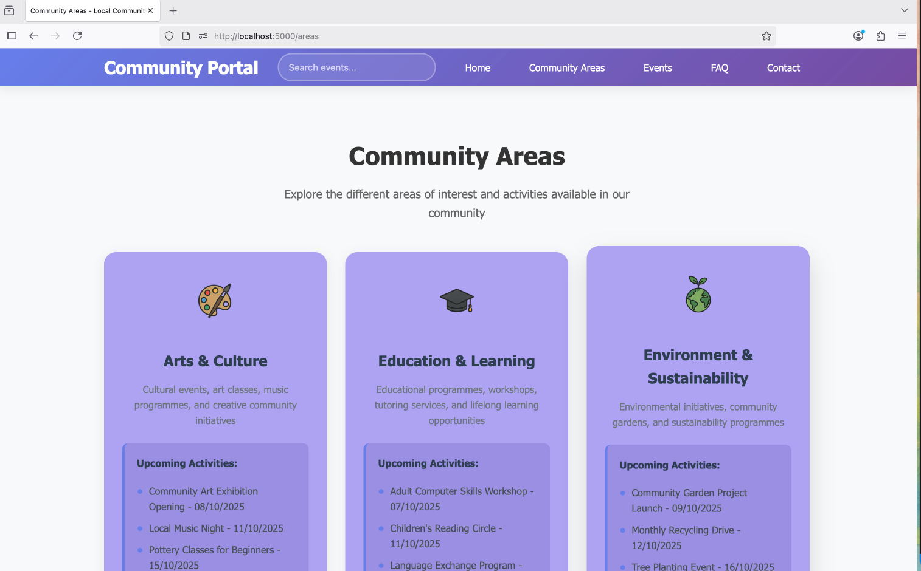

Figure : Community areas on Mozilla Firefox



Figure : Homepage on chrome

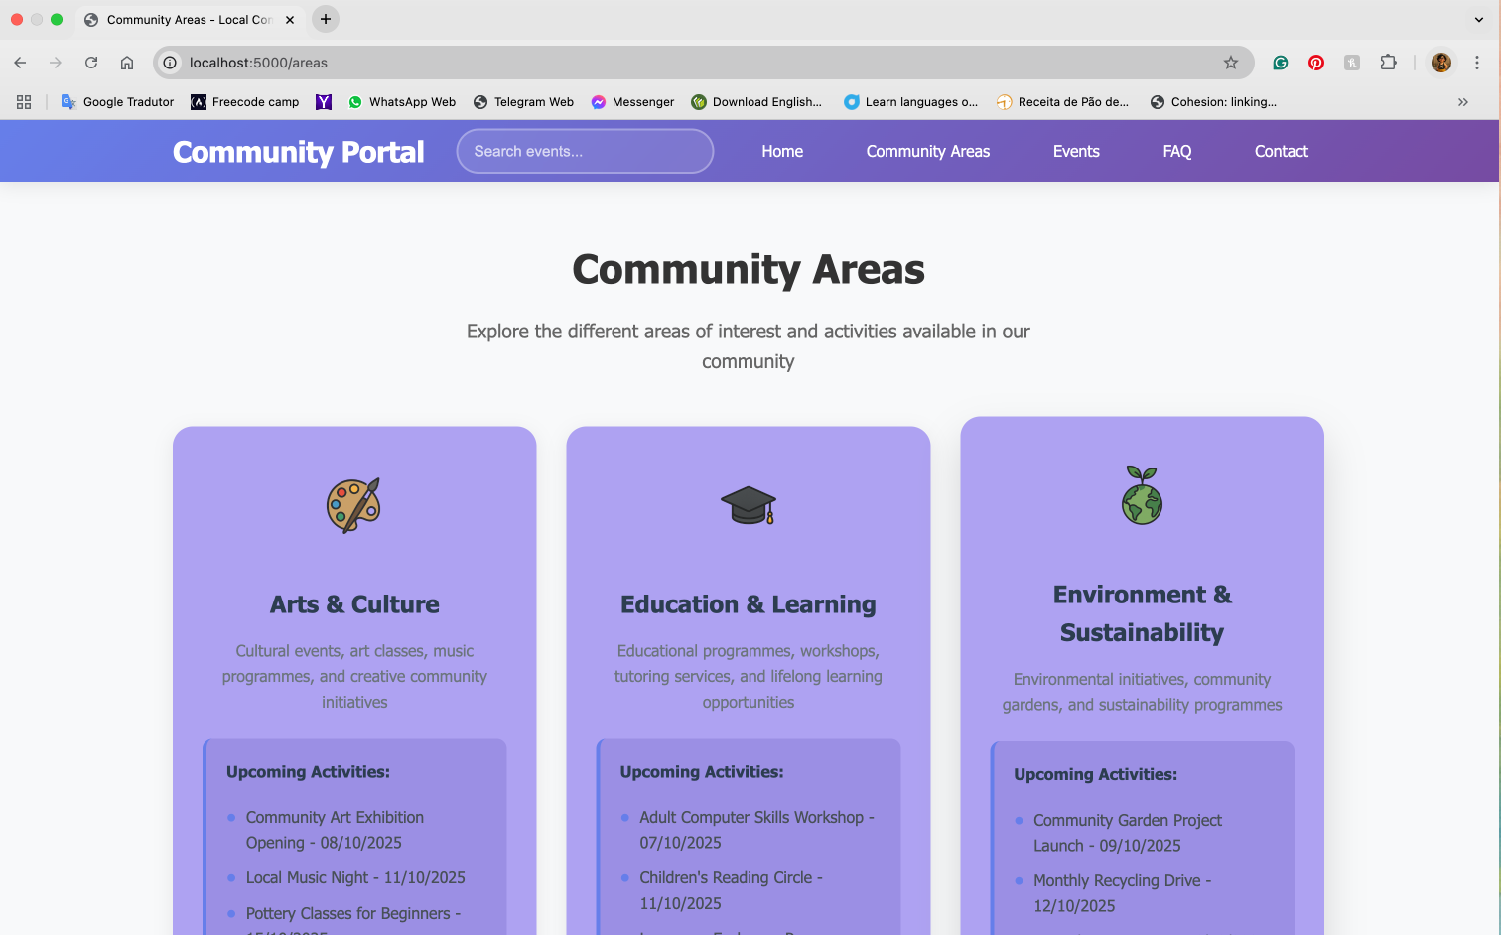

Figure : community areas chrome

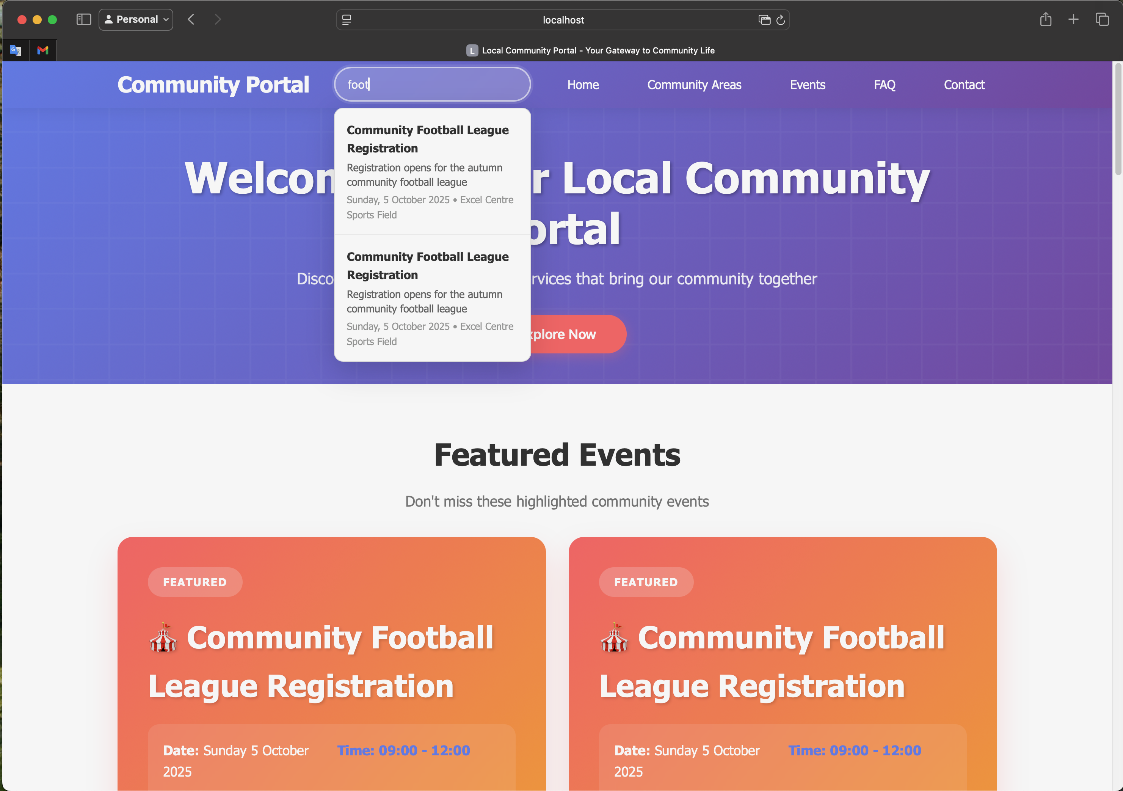

Figure : Homepage on Safari

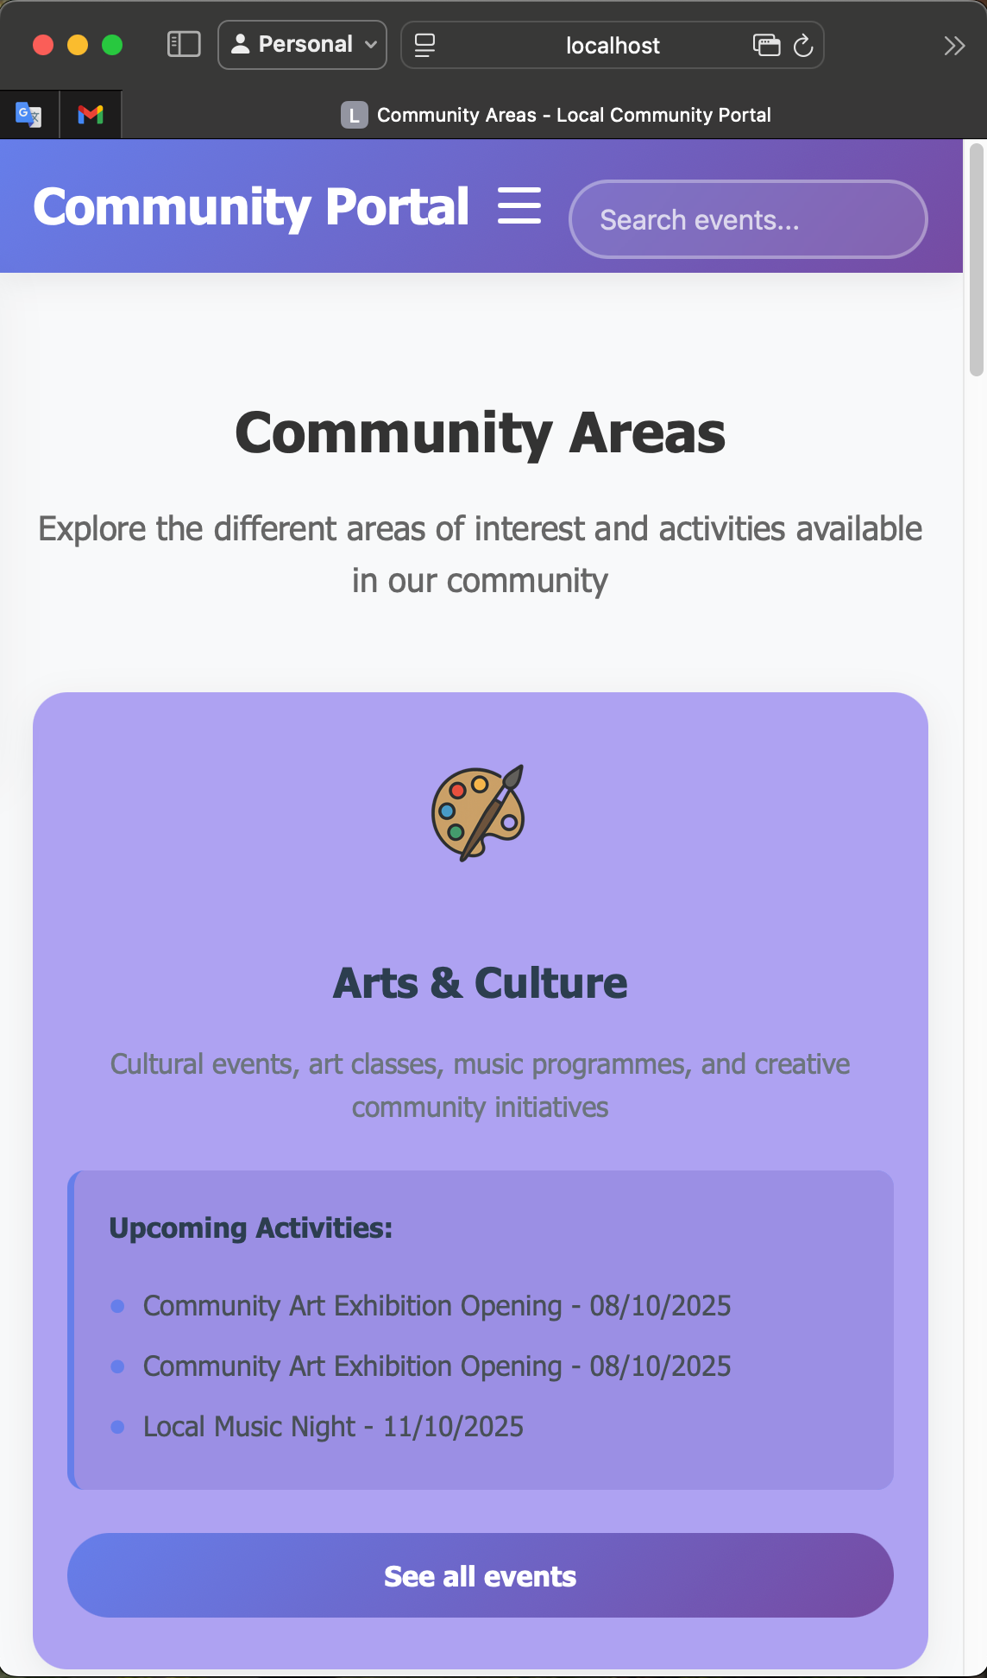

Figure : Mobile style community portal tested on Safari

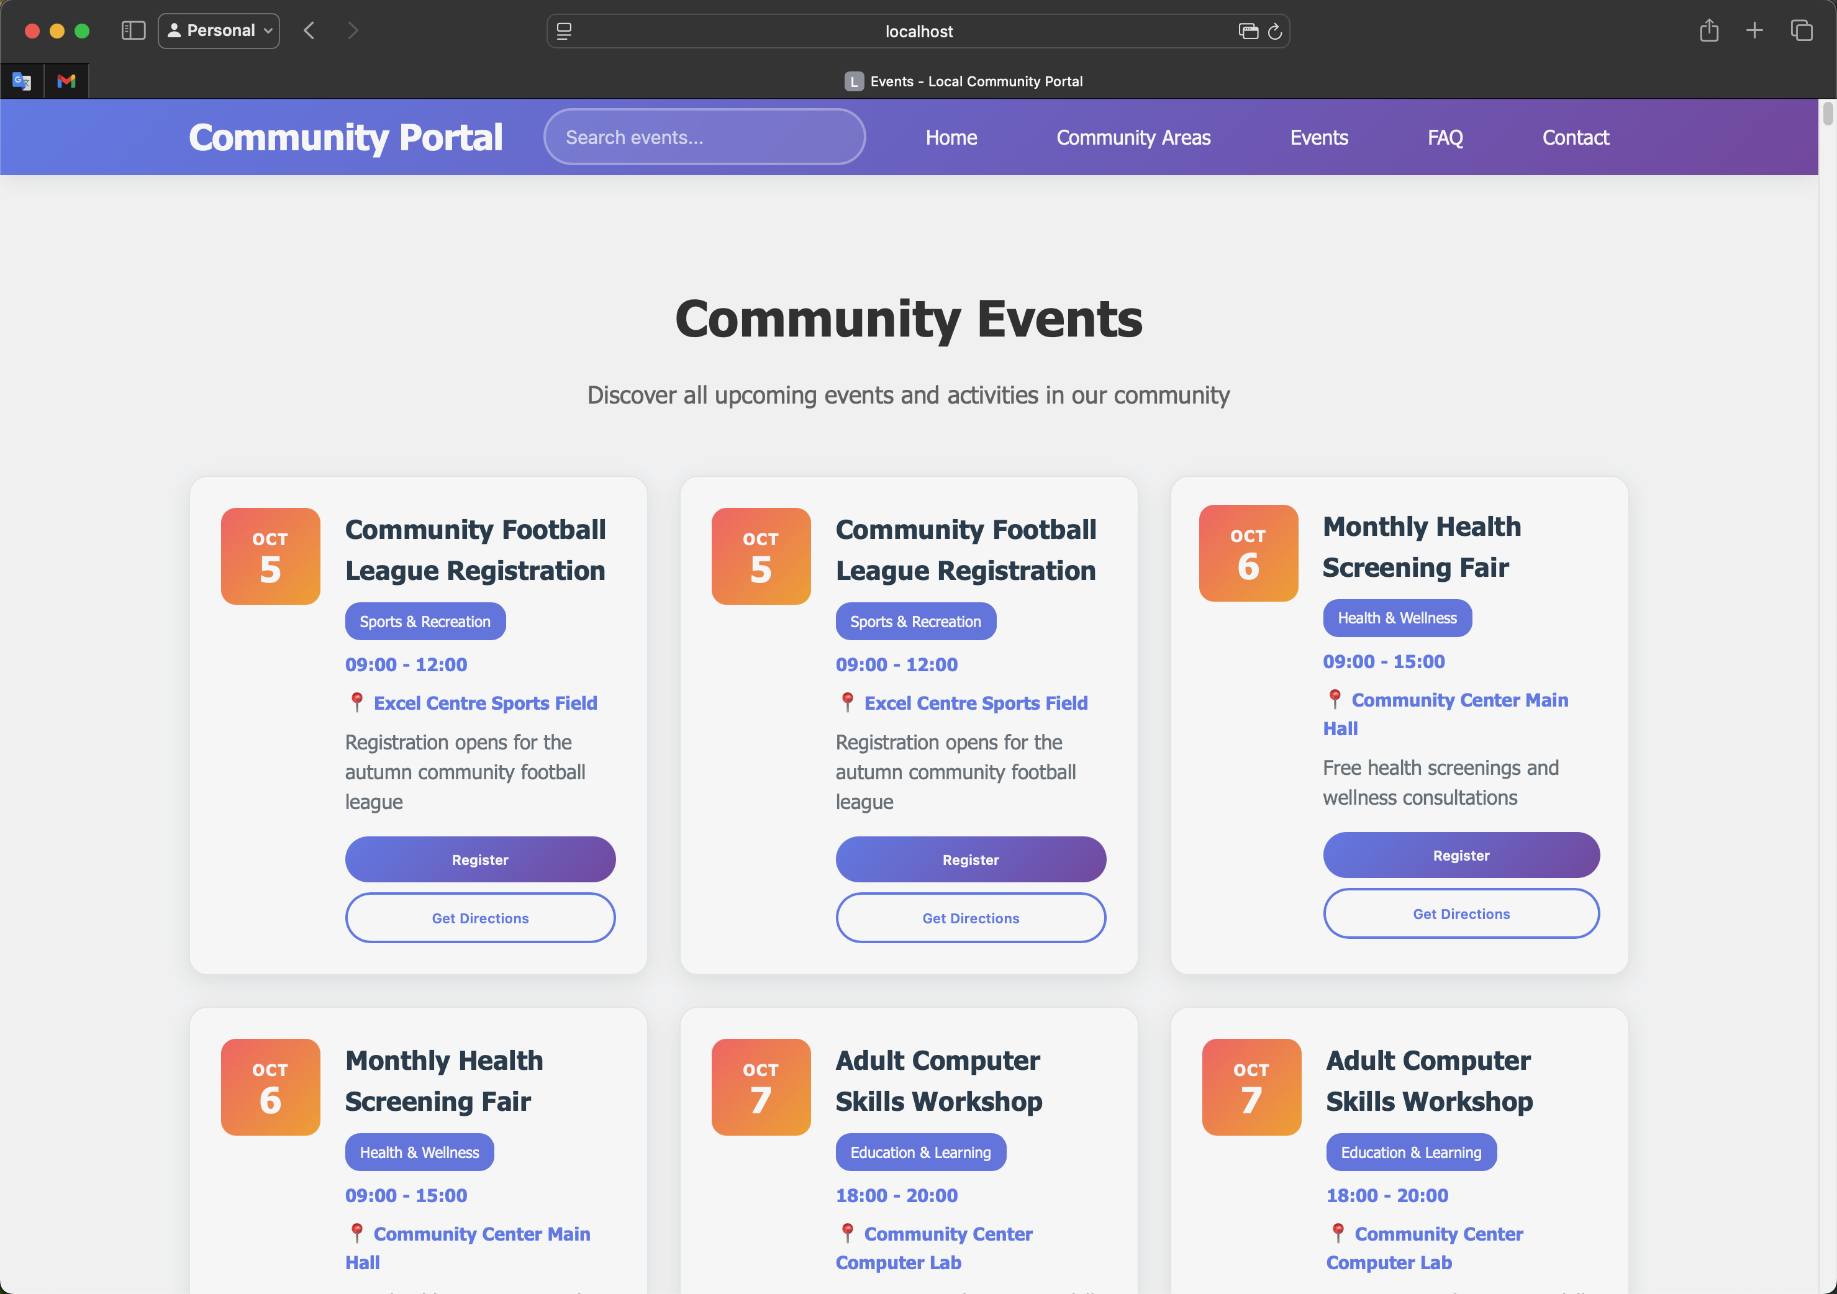

Figure : Community event on safari

# Proof conformity to W3C standards

The screenshots below, shows the HTML and CSS structures comply with the W3C Standards

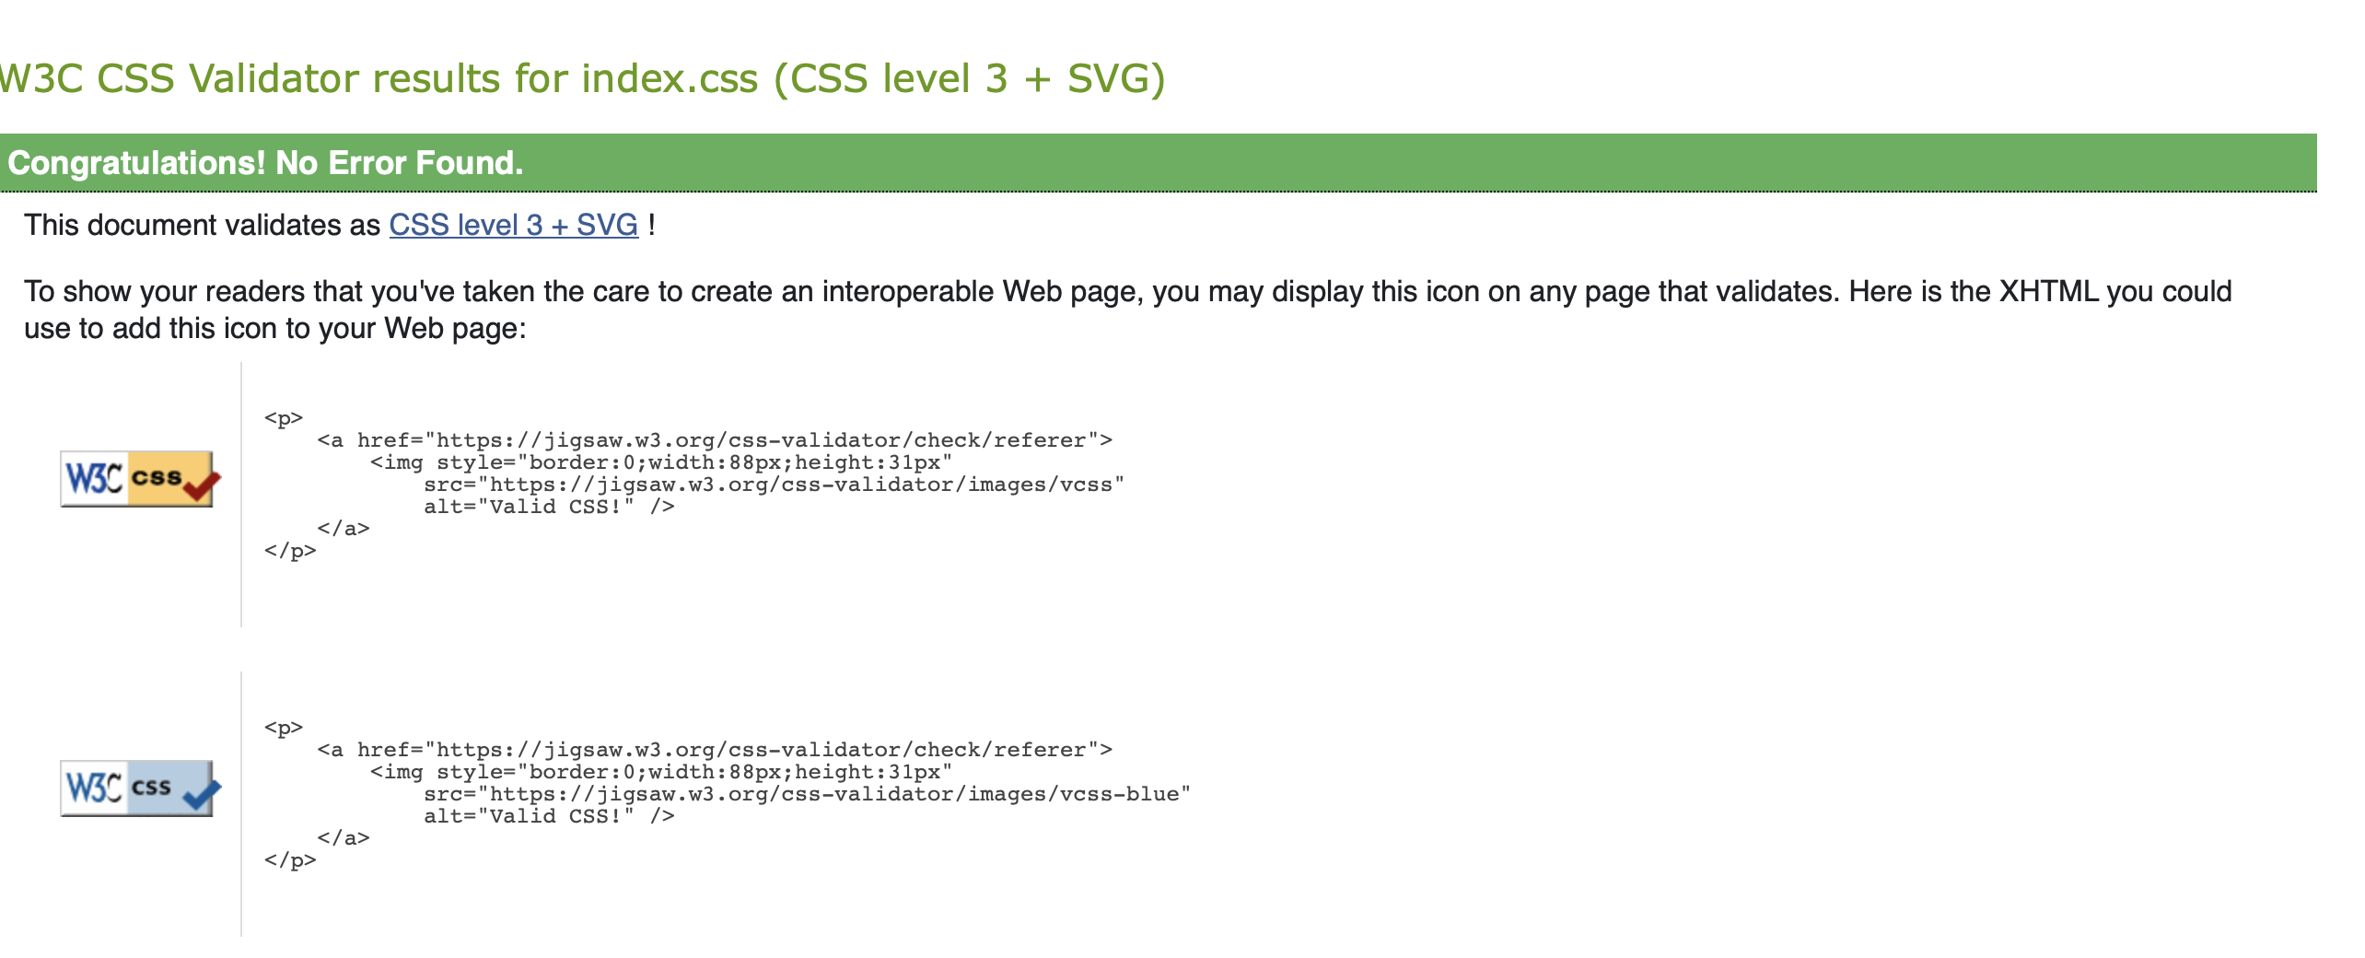

Figure : CSS Validator

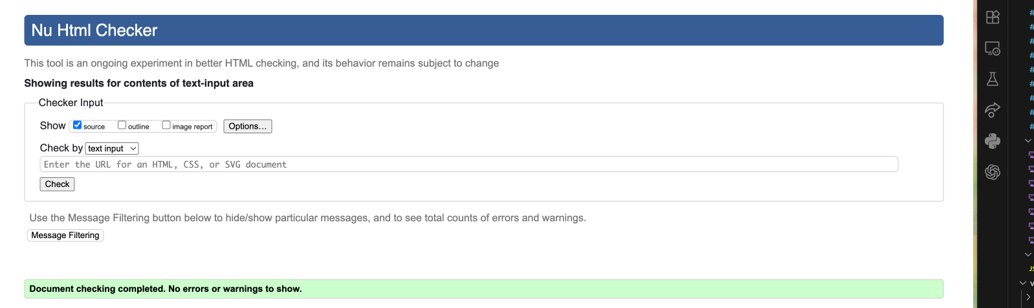

Figure : HTML Validator

However, if we test the entire will show some syntax errors, that happens because the project is using EJS format which the validator does not understand the EJS syntax.

# Contact Form with AJAX submission (Client–Server Database Interaction)

Client-side code controls what the user sees and how they interact, including layout, live validation, and the actual sending of data. The server-side code securely stores the message, performs final validation, and returns a response. This separation enables the interface to remain fast for users while ensuring data integrity and security on the backend.

The contact form is built using a mix of HTML, CSS, and JavaScript on the client side, alongside database and API functionality on the server side.

* Client-Side:

The HTML in the contact EJS outlines the visible form, featuring text fields for the user's name, email, and message, along with optional inputs for phone number and community area.

It also includes checkboxes for signing up for a newsletter and agreeing to privacy terms, as well as buttons to submit or reset the form, plus a hidden area for success messages.

The design is made using CSS (contact.css), creating a responsive layout with red borders for errors, blue highlights when fields are focused, and green animations for successful submissions.

JavaScript plays a crucial role in real-time validation of the form. It checks that all required fields are completed, verifies the email format using a regular expression, and ensures that the privacy agreement is accepted.

Event listeners help erase error messages as the user types.

Once everything is validated, an AJAX call (using fetch()) sends the data to the server in JSON format, showing a “Sending…” message while waiting for a response.

This whole layer—the layout, styling, instant feedback, and the AJAX call—is handled entirely on the client side, operating directly in the user's browser.

* Server-Side:

When the AJAX request is made, it reaches a backend route like */message*. A server framework, such as Express.js, takes in the JSON data, performs further validation and sanitization, and adds a new entry to the *contact_messages* database table.

The server is responsible for managing logs, handling errors, and implementing security measures to prevent threats such as SQL injection and cross-site scripting.

After processing the data, it replies with a JSON response indicating whether the operation was successful or not

Below the screenshot showing the database updating according to data typed on contact form.

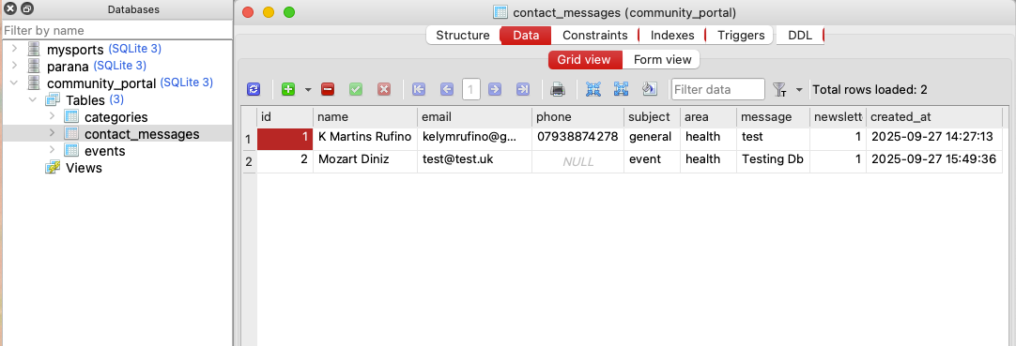

Figure : valid data input on database

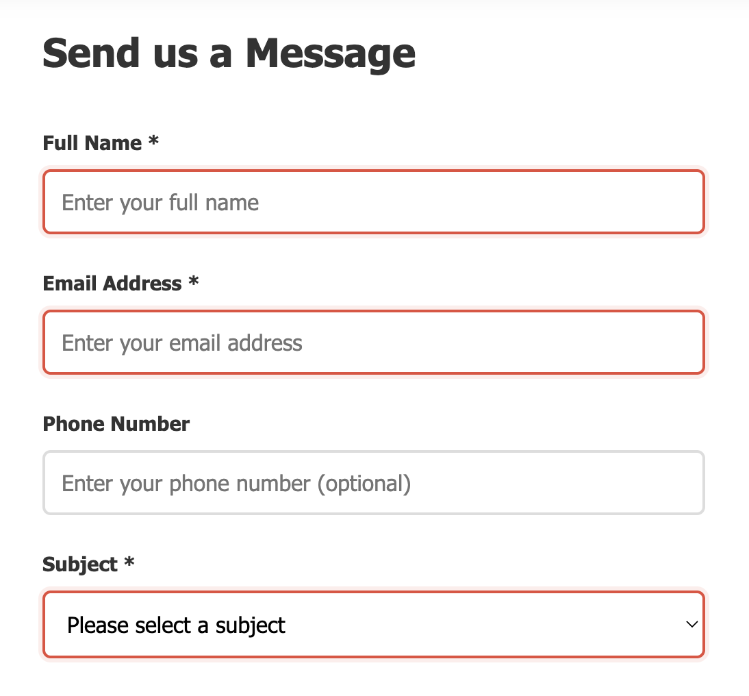

Figure : showing error validating the form

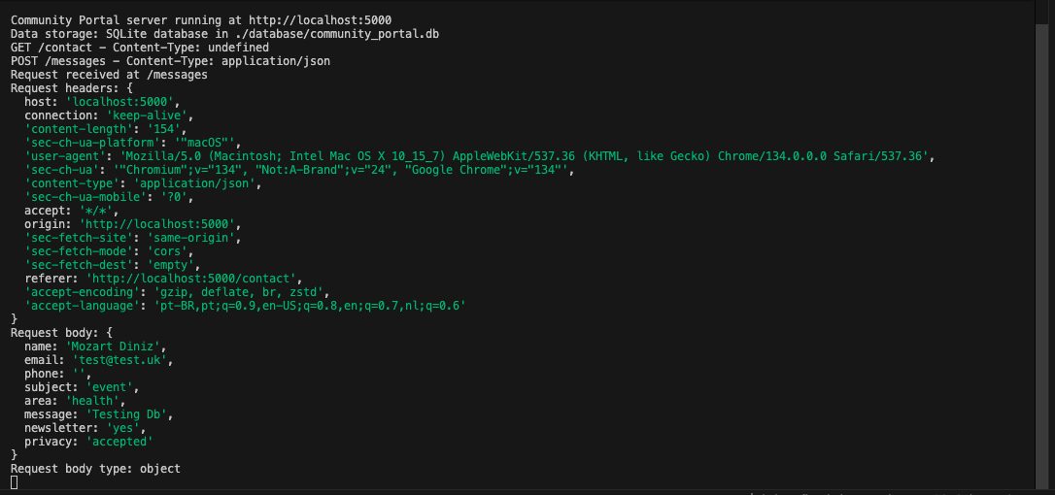

Figure : Console showing successful and unsuccessful fetch

# Live Event Search with AJAX (Client–Server Database Interaction)

Another feature that has been used client-server database was to search the live events on the page, the client side handles the user interface, detects typing, sends requests, and displays results in real-time. Meanwhile, the server side verifies input, queries the database, filters the outcomes, and generates the JSON response. Together, they deliver immediate and seamless search feedback without needing to reload the page.

* Server-Side (Node.js/Express)

The backend provides an endpoint at /api/search. When a request is received, Express processes the query parameters—q for the search term and an optional category. It invokes *DatabaseService.searchEvents(),* which executes SQL queries to find matches in event titles, descriptions, and locations, and can also search within community-area data. If a category is specified, the server narrows down the results accordingly. A JSON response containing all relevant records is then returned. The server also handles input validation, manages unforeseen errors effectively, and mitigates security risks, such as SQL injection. All interactions with the database and error logging take place here, remaining unseen by the user.

* Client-Side(JavaScript/AJAX)

On the client side, JavaScript monitors the user's input in the search bar. To prevent overwhelming the server, it uses a technique called debouncing, which involves waiting approximately 300 milliseconds after the user has stopped typing before making a request. Once activated, the client submits an HTTP GET request to */api/search?q=searchterm&category=optional* using *fetch()* or a similar AJAX technique. When the JSON data is received, the script modifies the DOM of the page to immediately present the updated search results without the need to refresh. In cases where the request encounters an error, the client displays a user-friendly error notification.

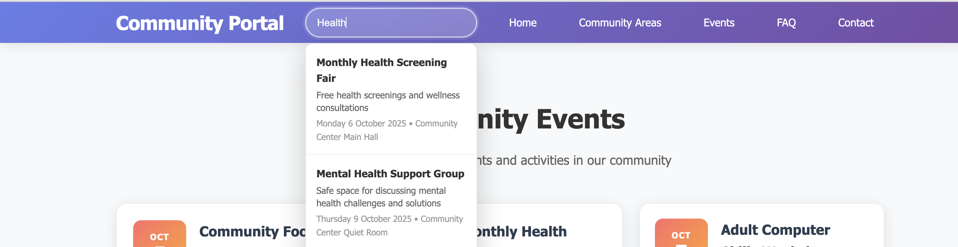

Figure : searching on the website

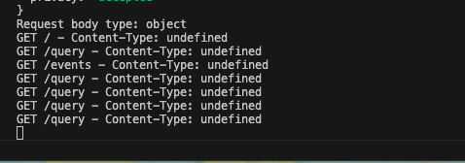

Figure : queries generated on console log

# Security considerations

Legal compliance is robust, featuring copyright-free icons and Unicode emojis, effective consent processes, references to privacy policies, and adherence to GDPR standards for data collection.

Accessibility meets WCAG 2.1 AA standards with alt text for images, semantic HTML usage, proper labelling of forms, responsive design suitable for mobile viewports, high colour contrast, and complete keyboard navigation.

Security measures are solid, encompassing both client and server-side input validation, the use of prepared statements to mitigate the risk of SQL injection, automatic HTML escaping to guard against XSS attacks, and secure error handling practices.

Ethical considerations are well-addressed through inclusive design that caters to diverse community needs, clear communication of event details and contact information, and free access to promote digital equity.

Notable strengths include thorough form validation that enhances user experience and security, proper semantic structure in HTML, responsive accessibility across all devices, and secure database management employing parameterized queries.

# ERD showing the database structure

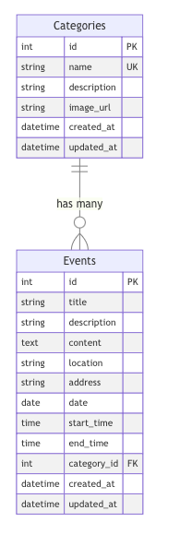

Figure : ERD database structure generated on mermaidchart.com

# AI usage

On this project I have use AI to help me to create a database and to generate random events to show on events page.

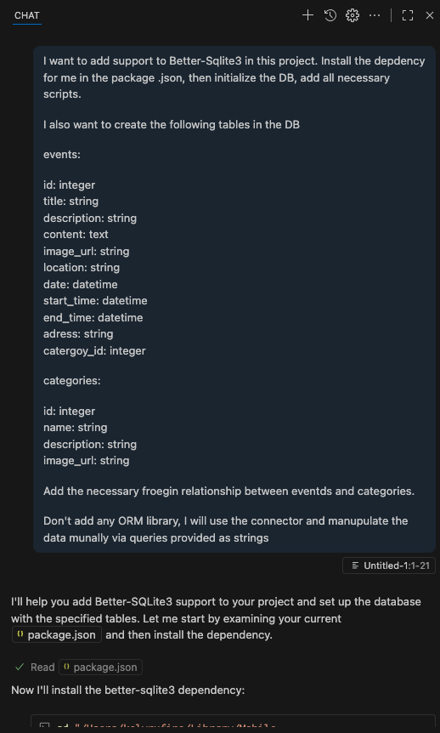

Figure : agent Claude Sonnet4 on VS Code

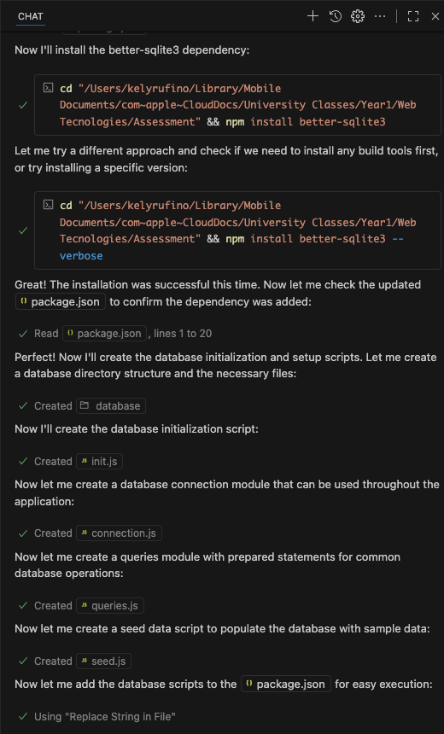

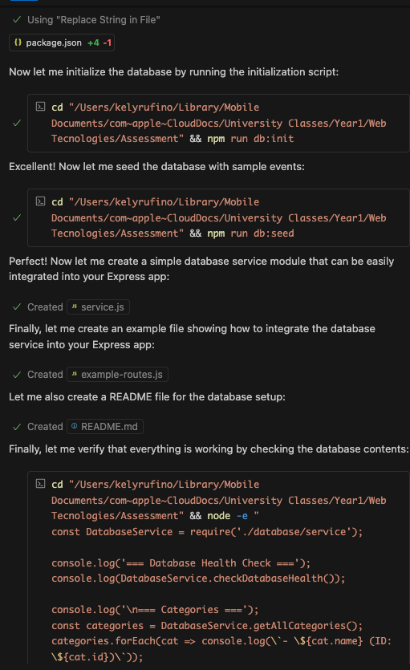

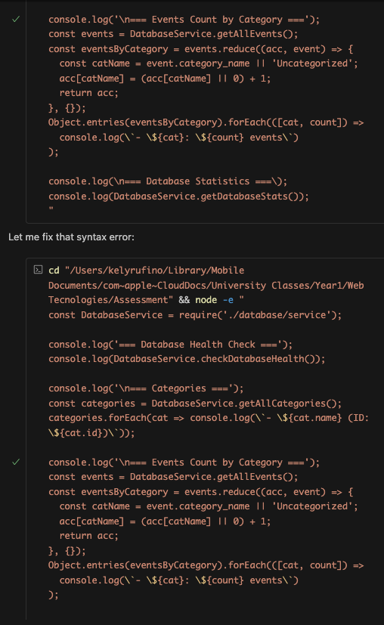

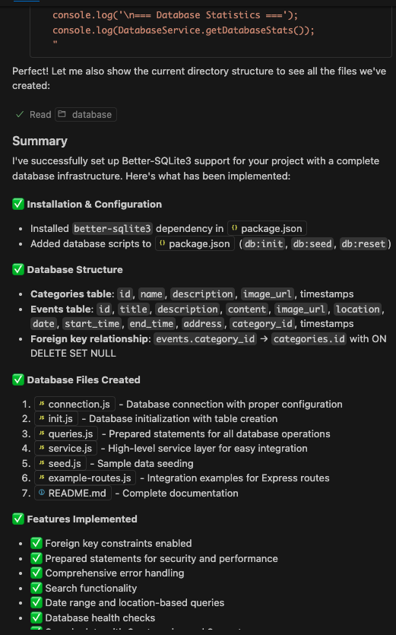  
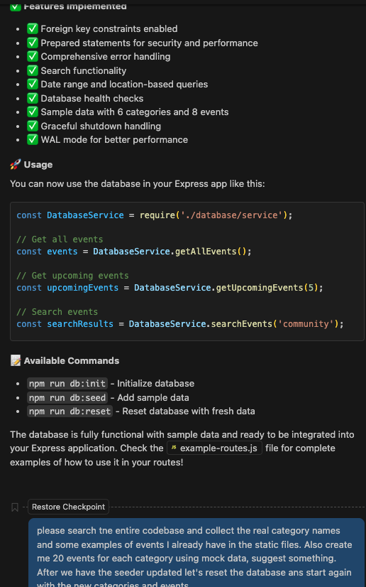

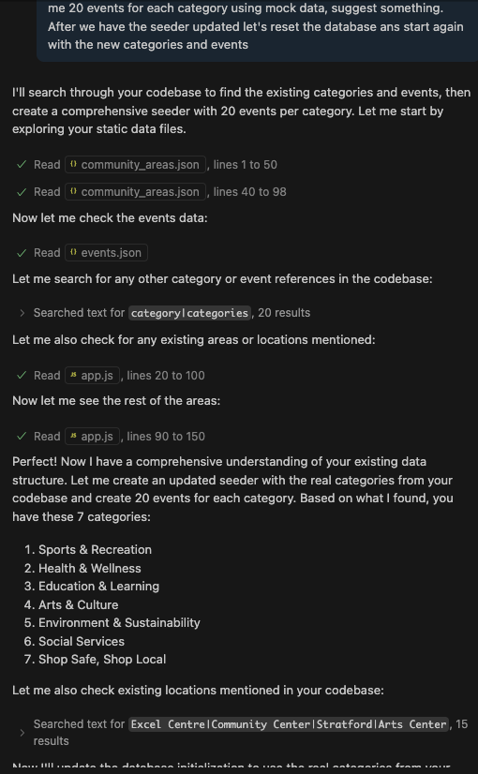

The Ai was used to remove the JSON files as used to work as database, when I migrate to SQLITE3 I asked to AI remove the folders containing JSON files

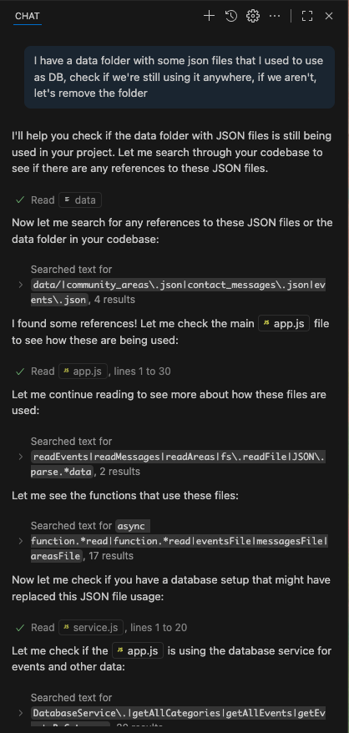

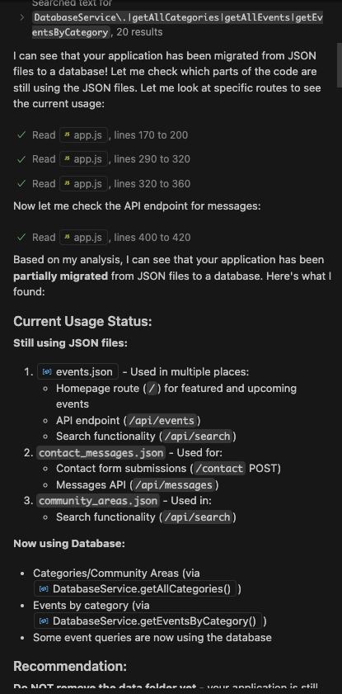

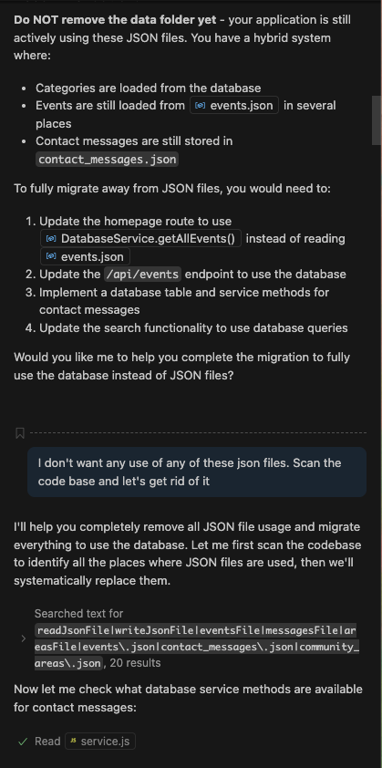

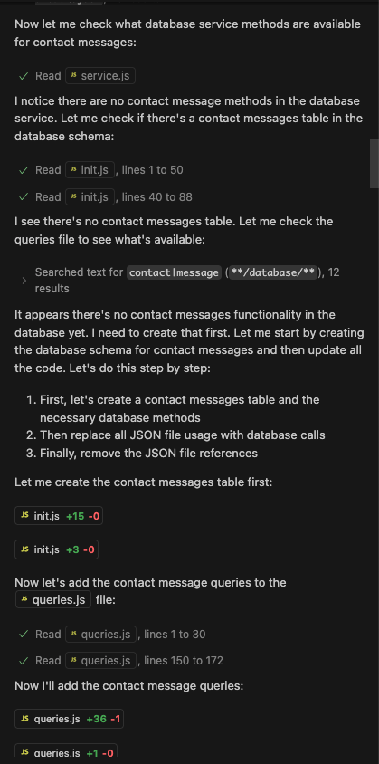

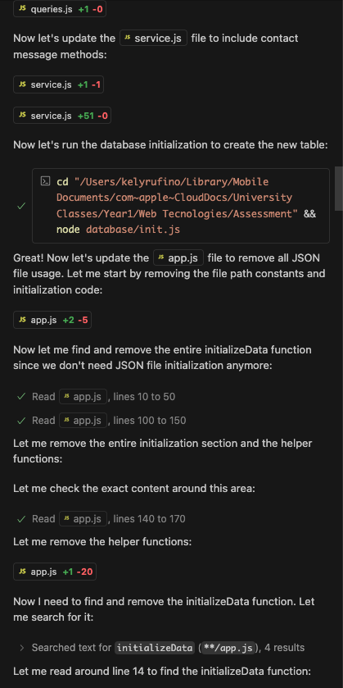

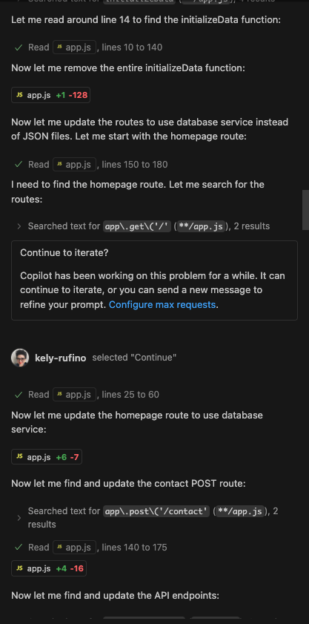

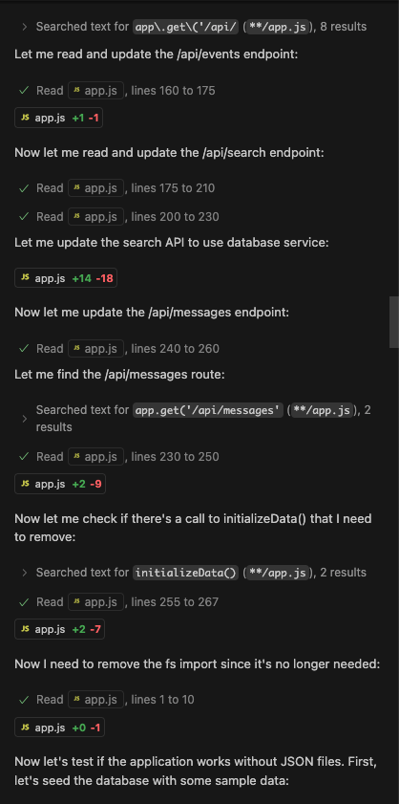

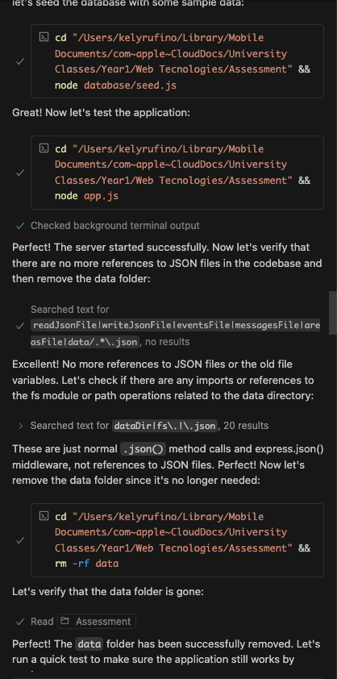

The GitHub repository can be seen on: **https://github.com/kely-rufino/WebTechnologies**

[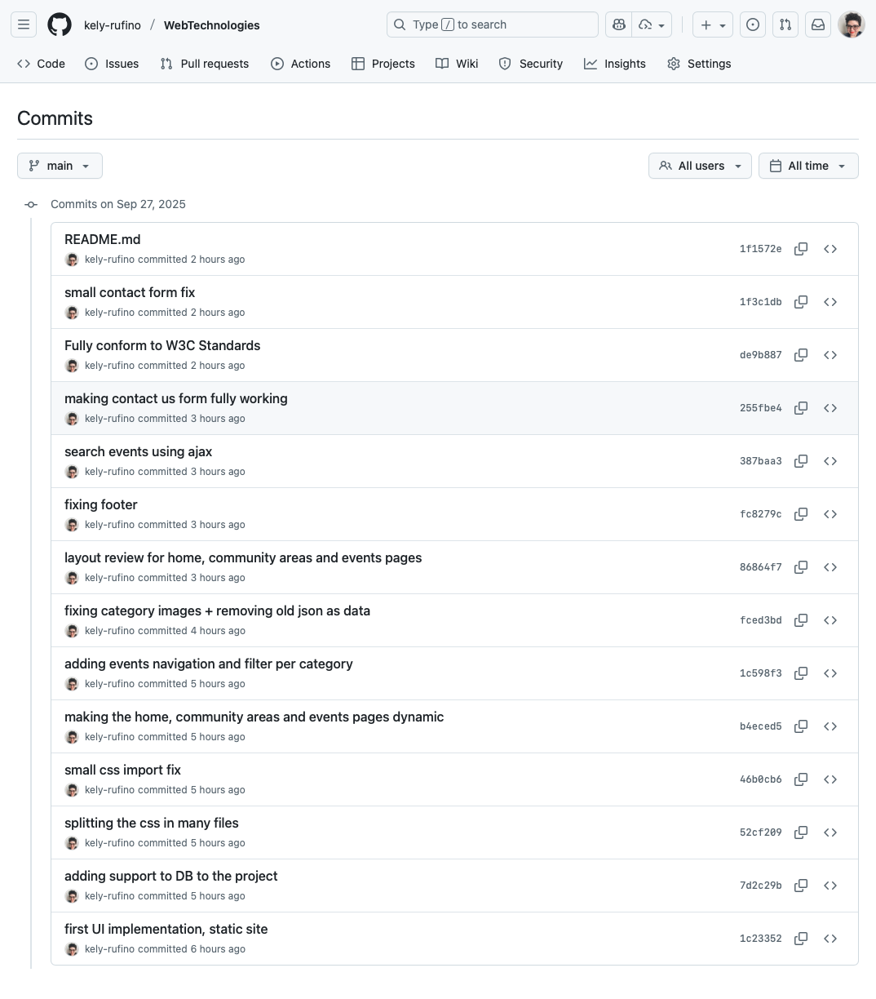](https://github.com/kely-rufino/WebTechnologies/commits/main/)

AI was not used to create the main code on this project.